**Object-Oriented Programming**

Lab 01: Environment Setup and Java Basics

***2.2.5:*** Write a program to calculate sum, difference, product, and quotient of 2 double numbers which are entered by users:

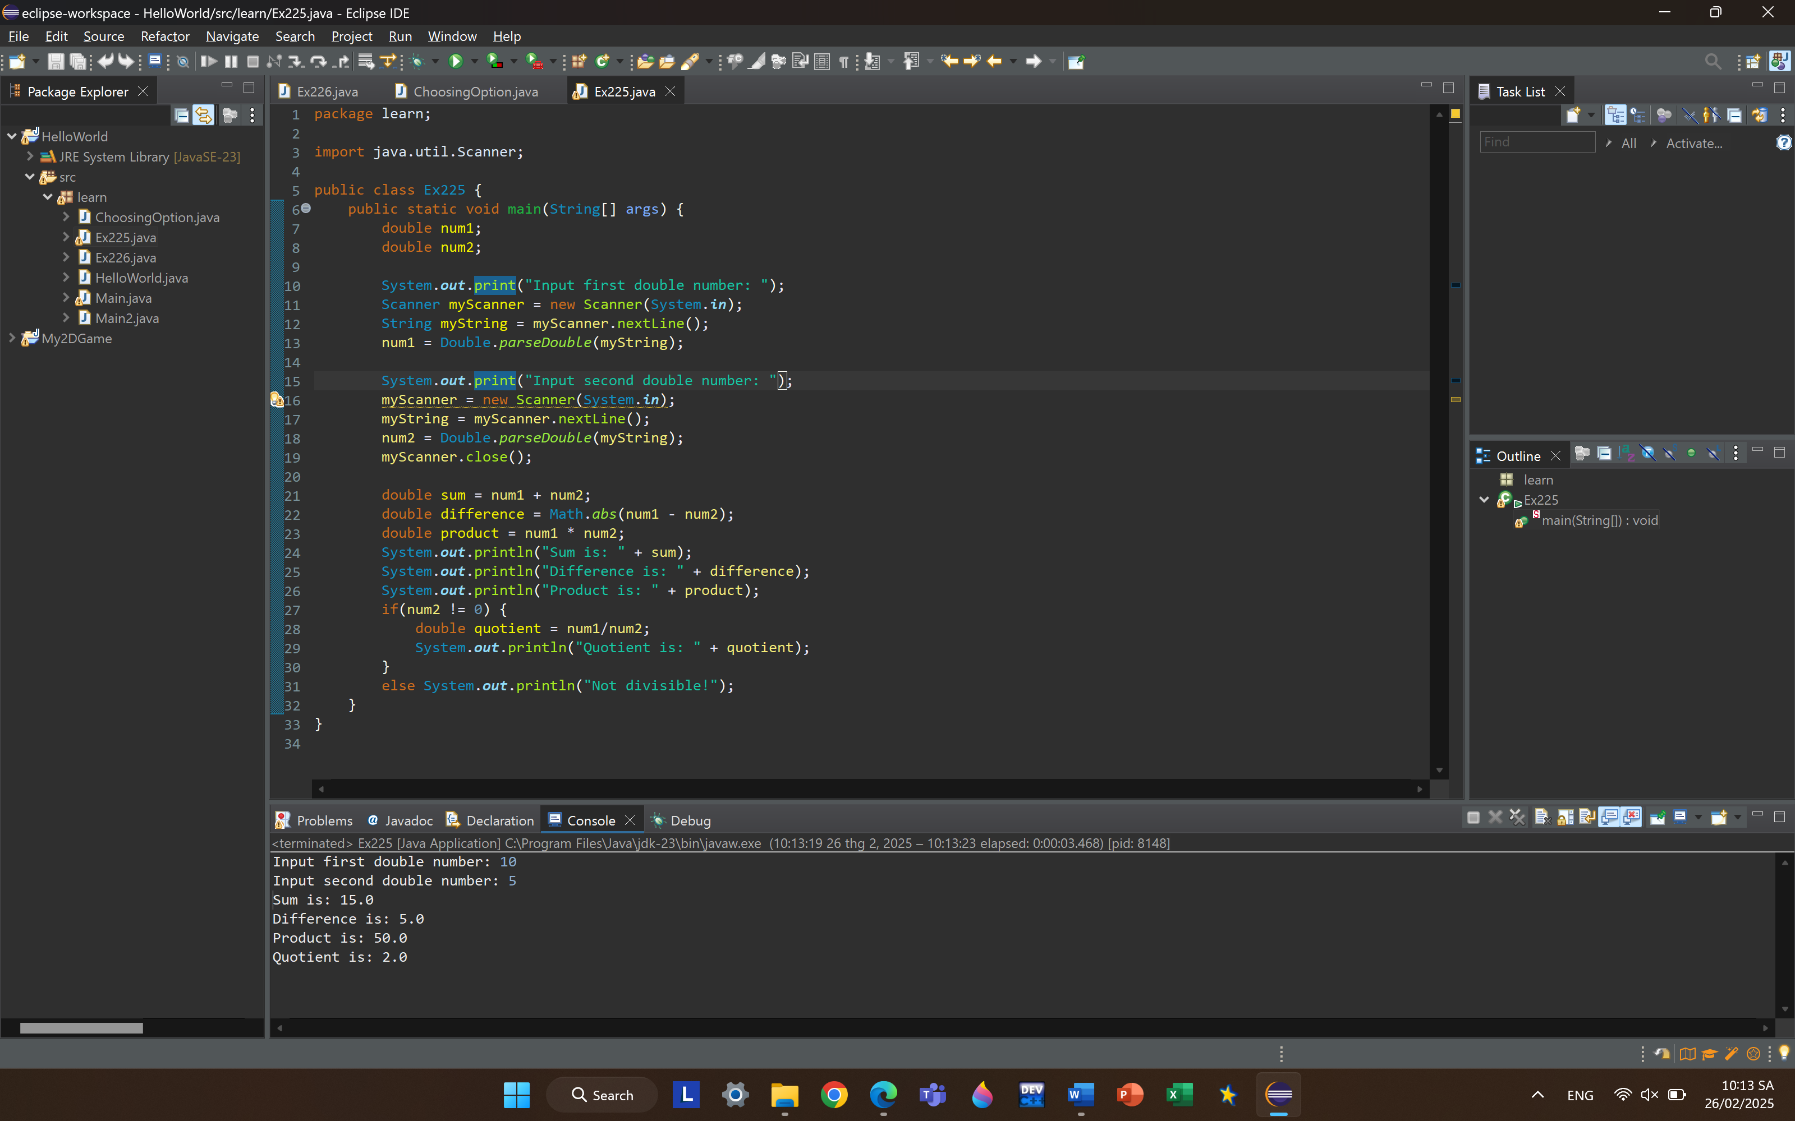

***2.2.6:*** Write a program to solve:

* The first-degree equation (linear equation) with one variable:

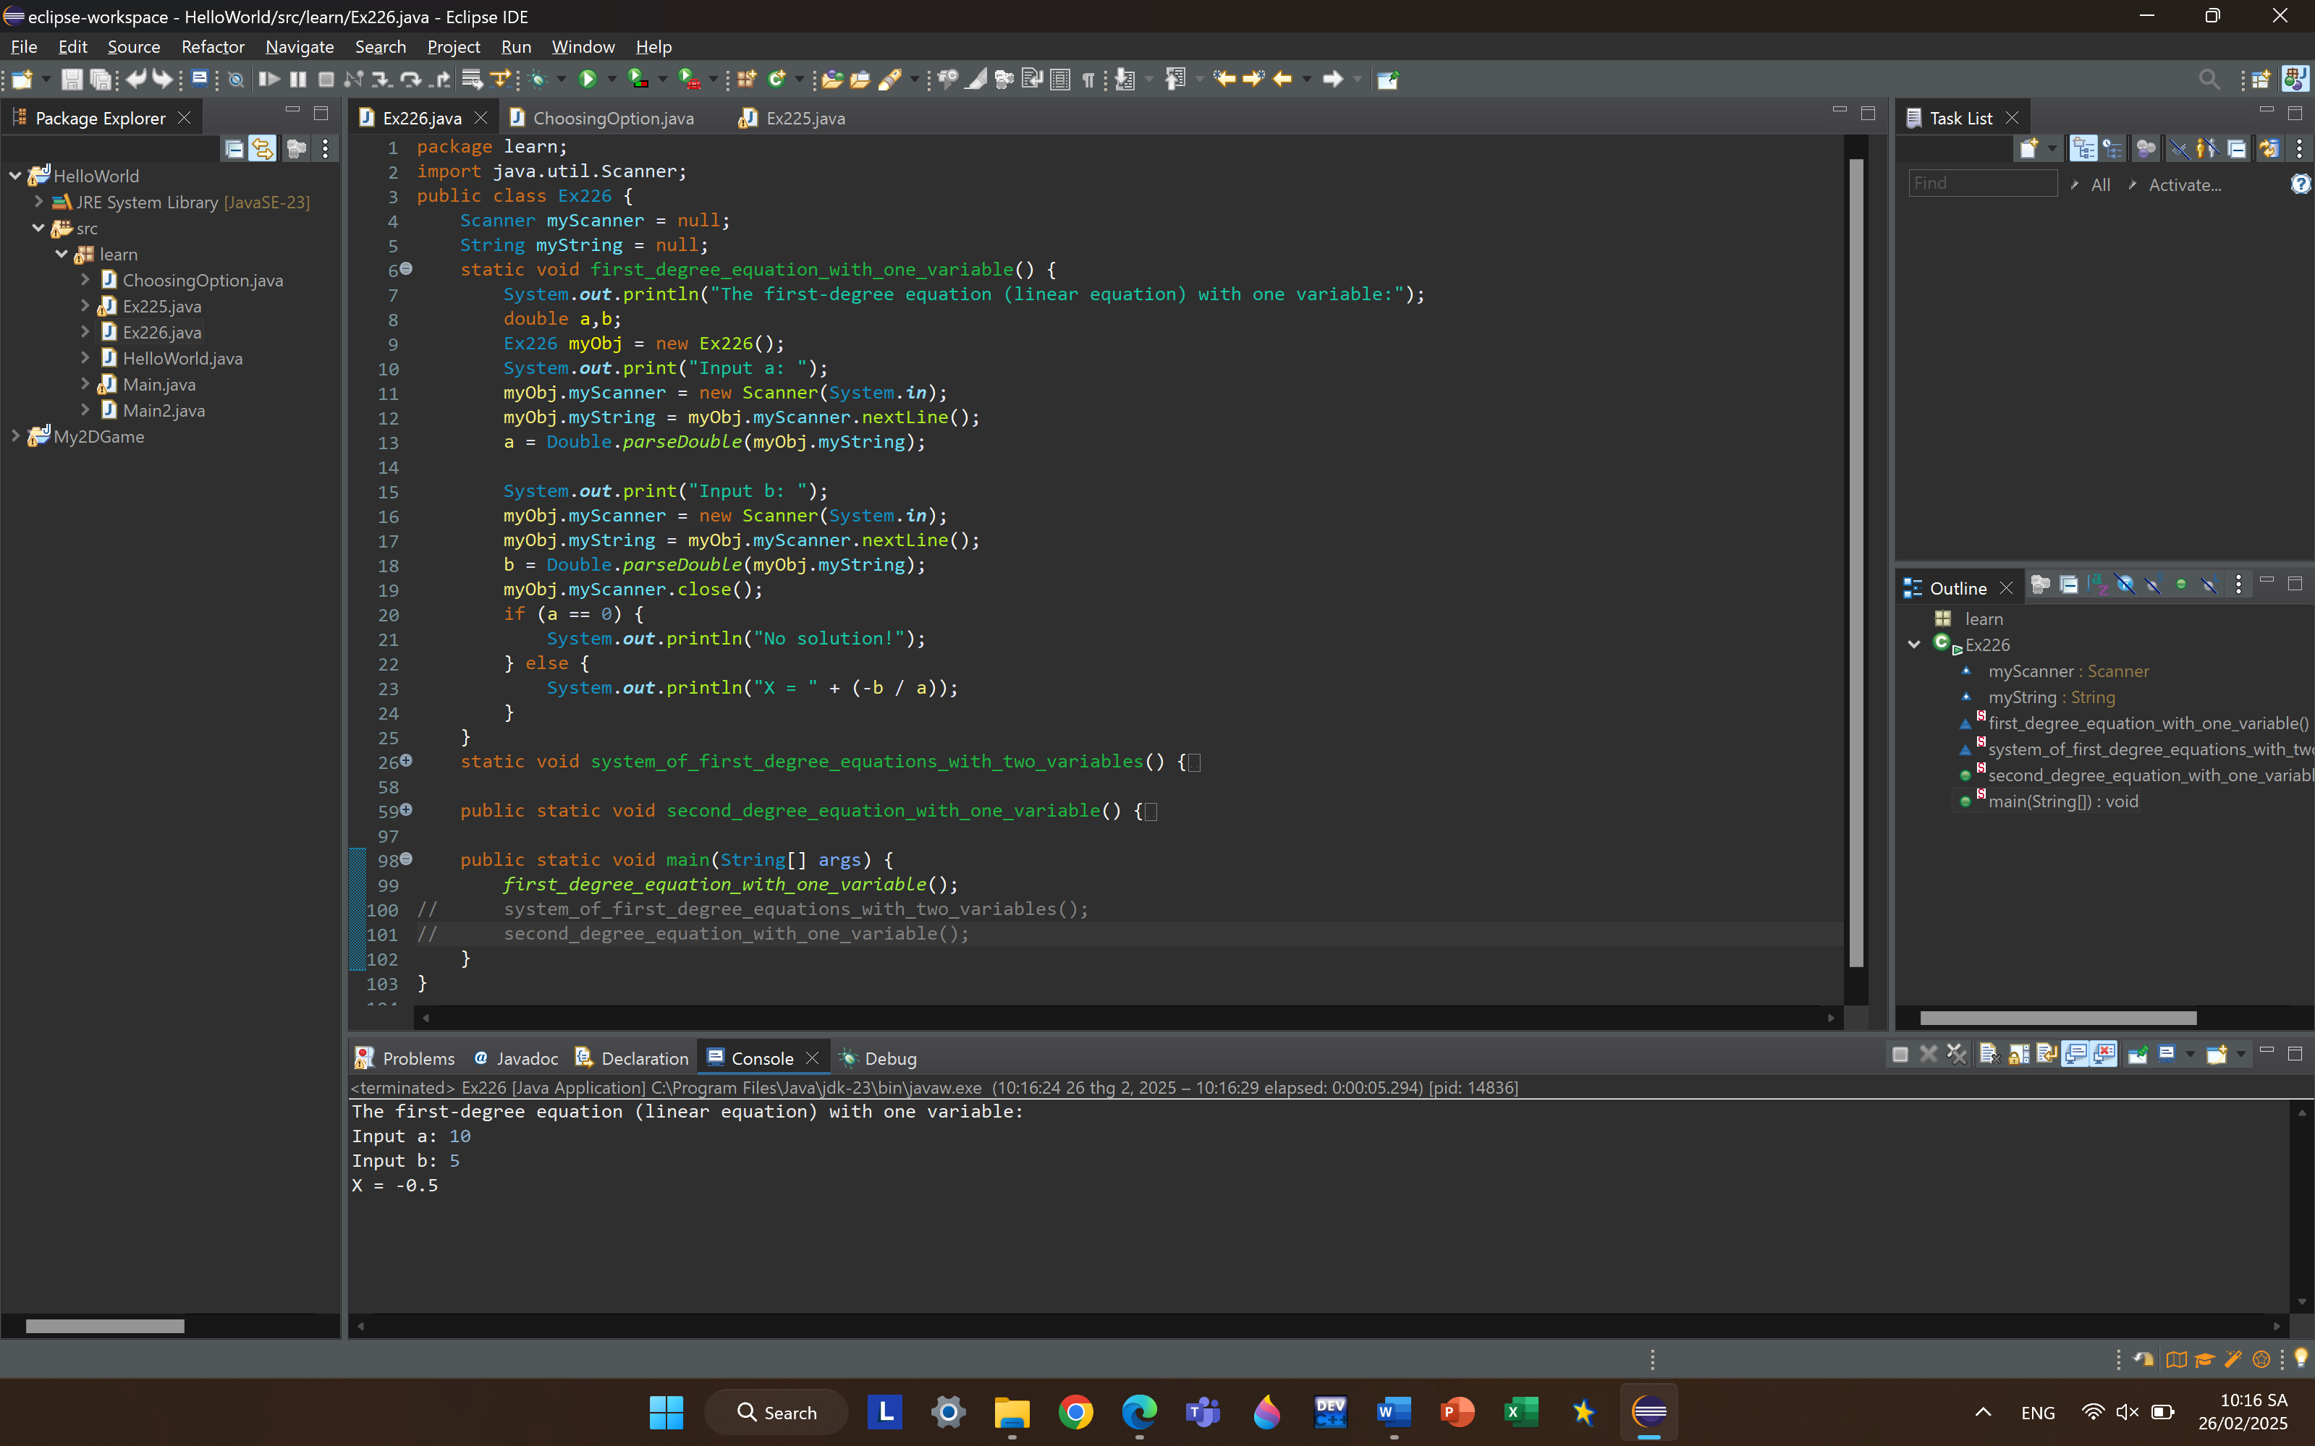

* The system of first-degree equations (linear system) with two variables:

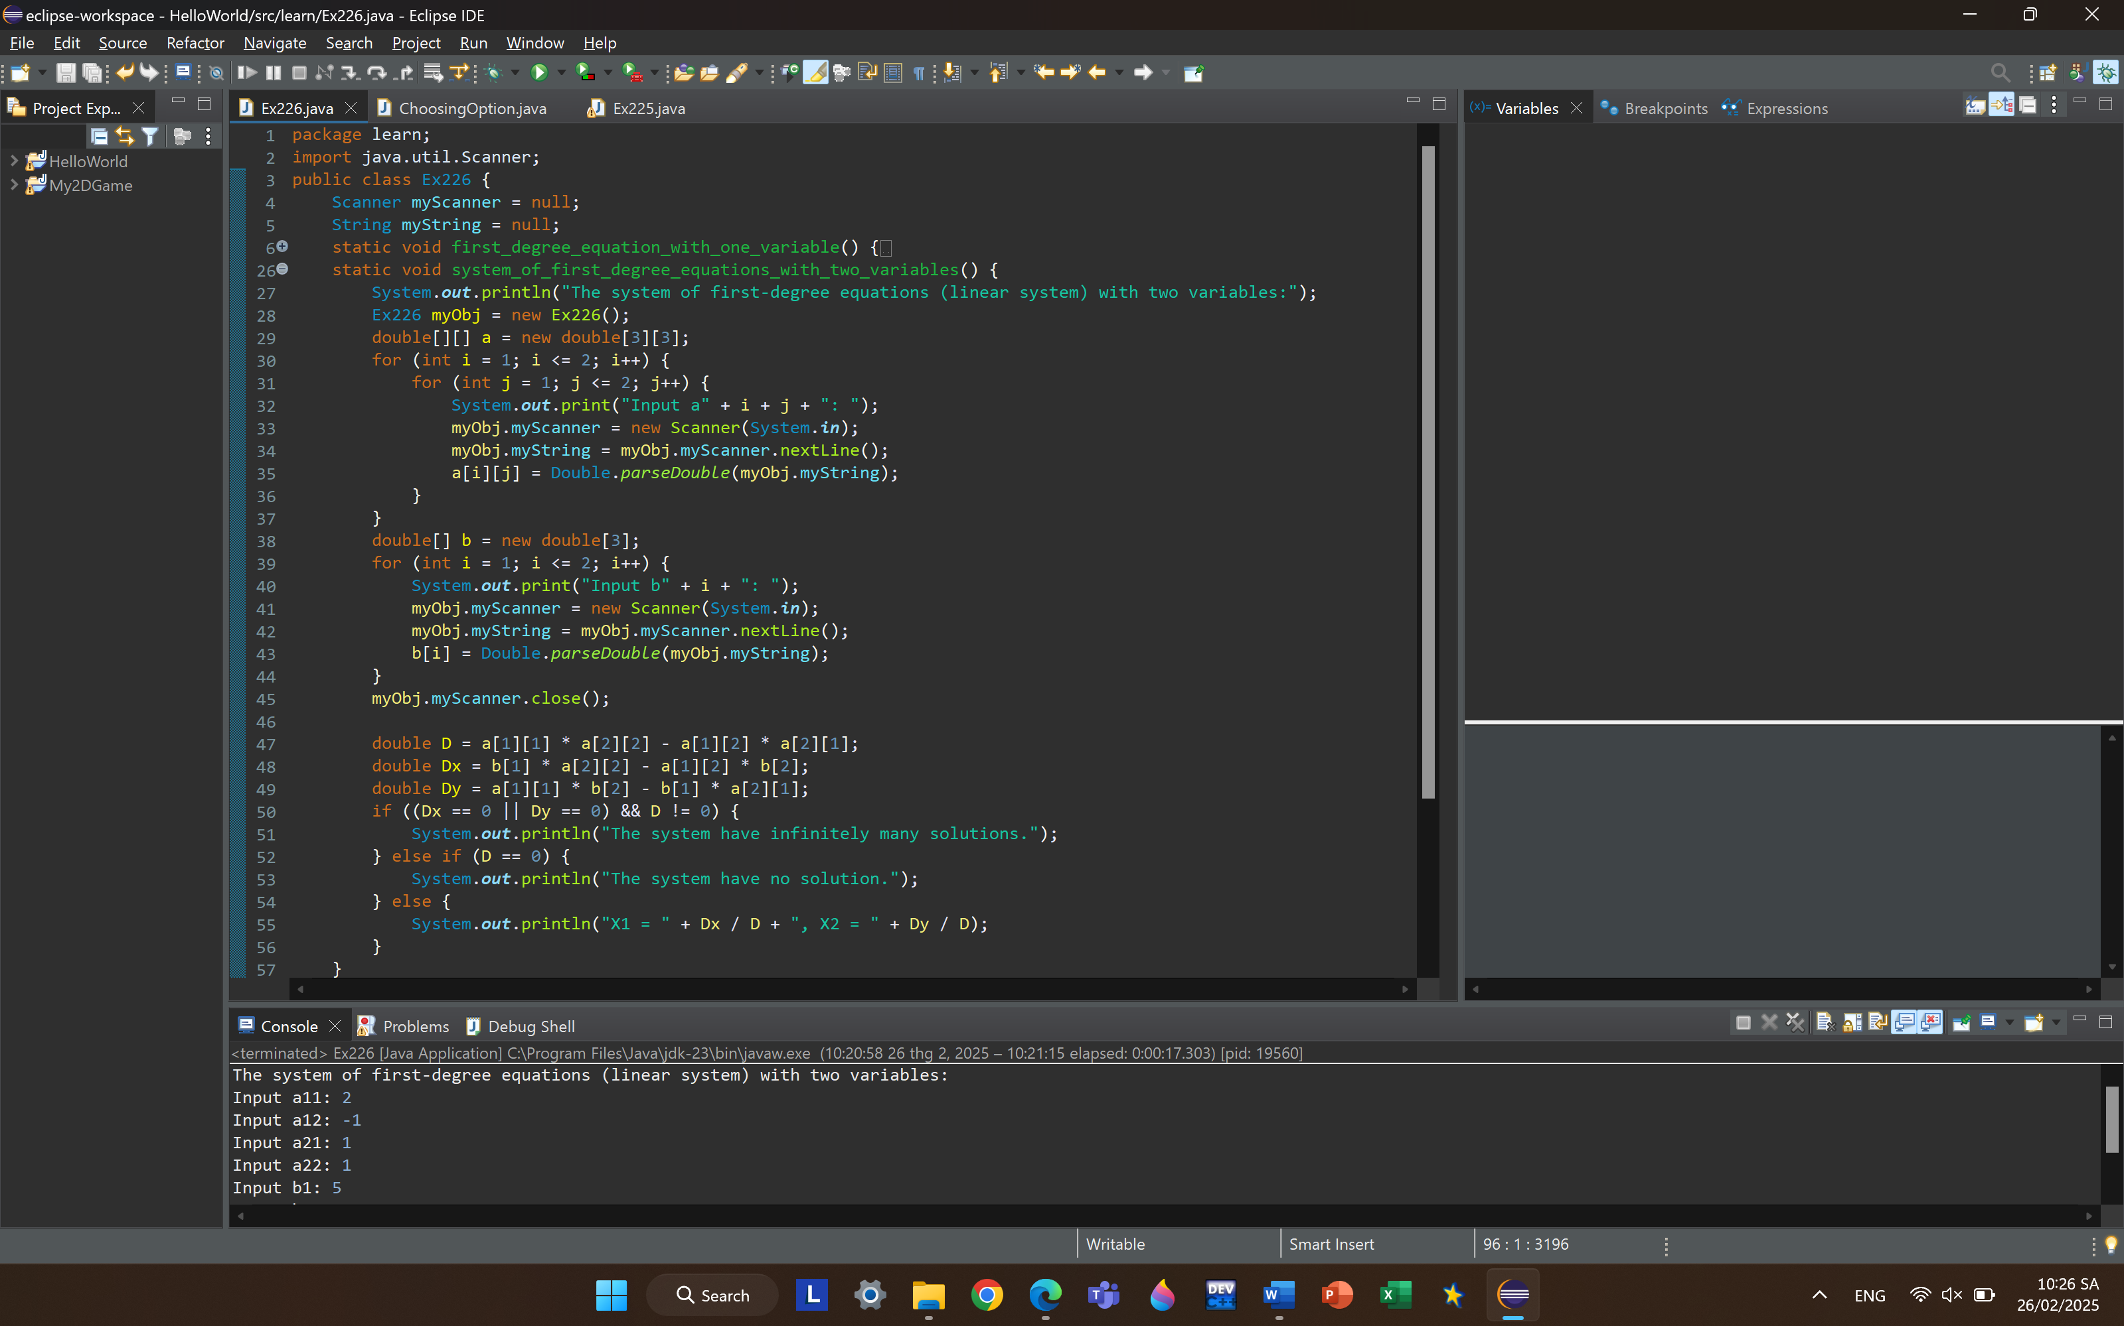

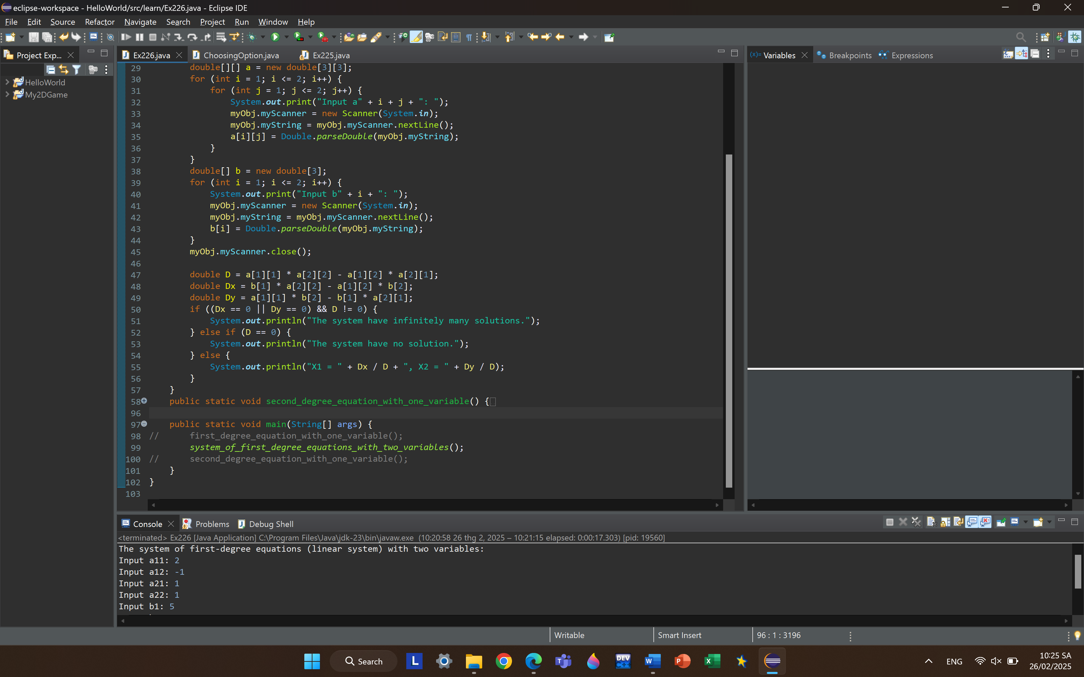

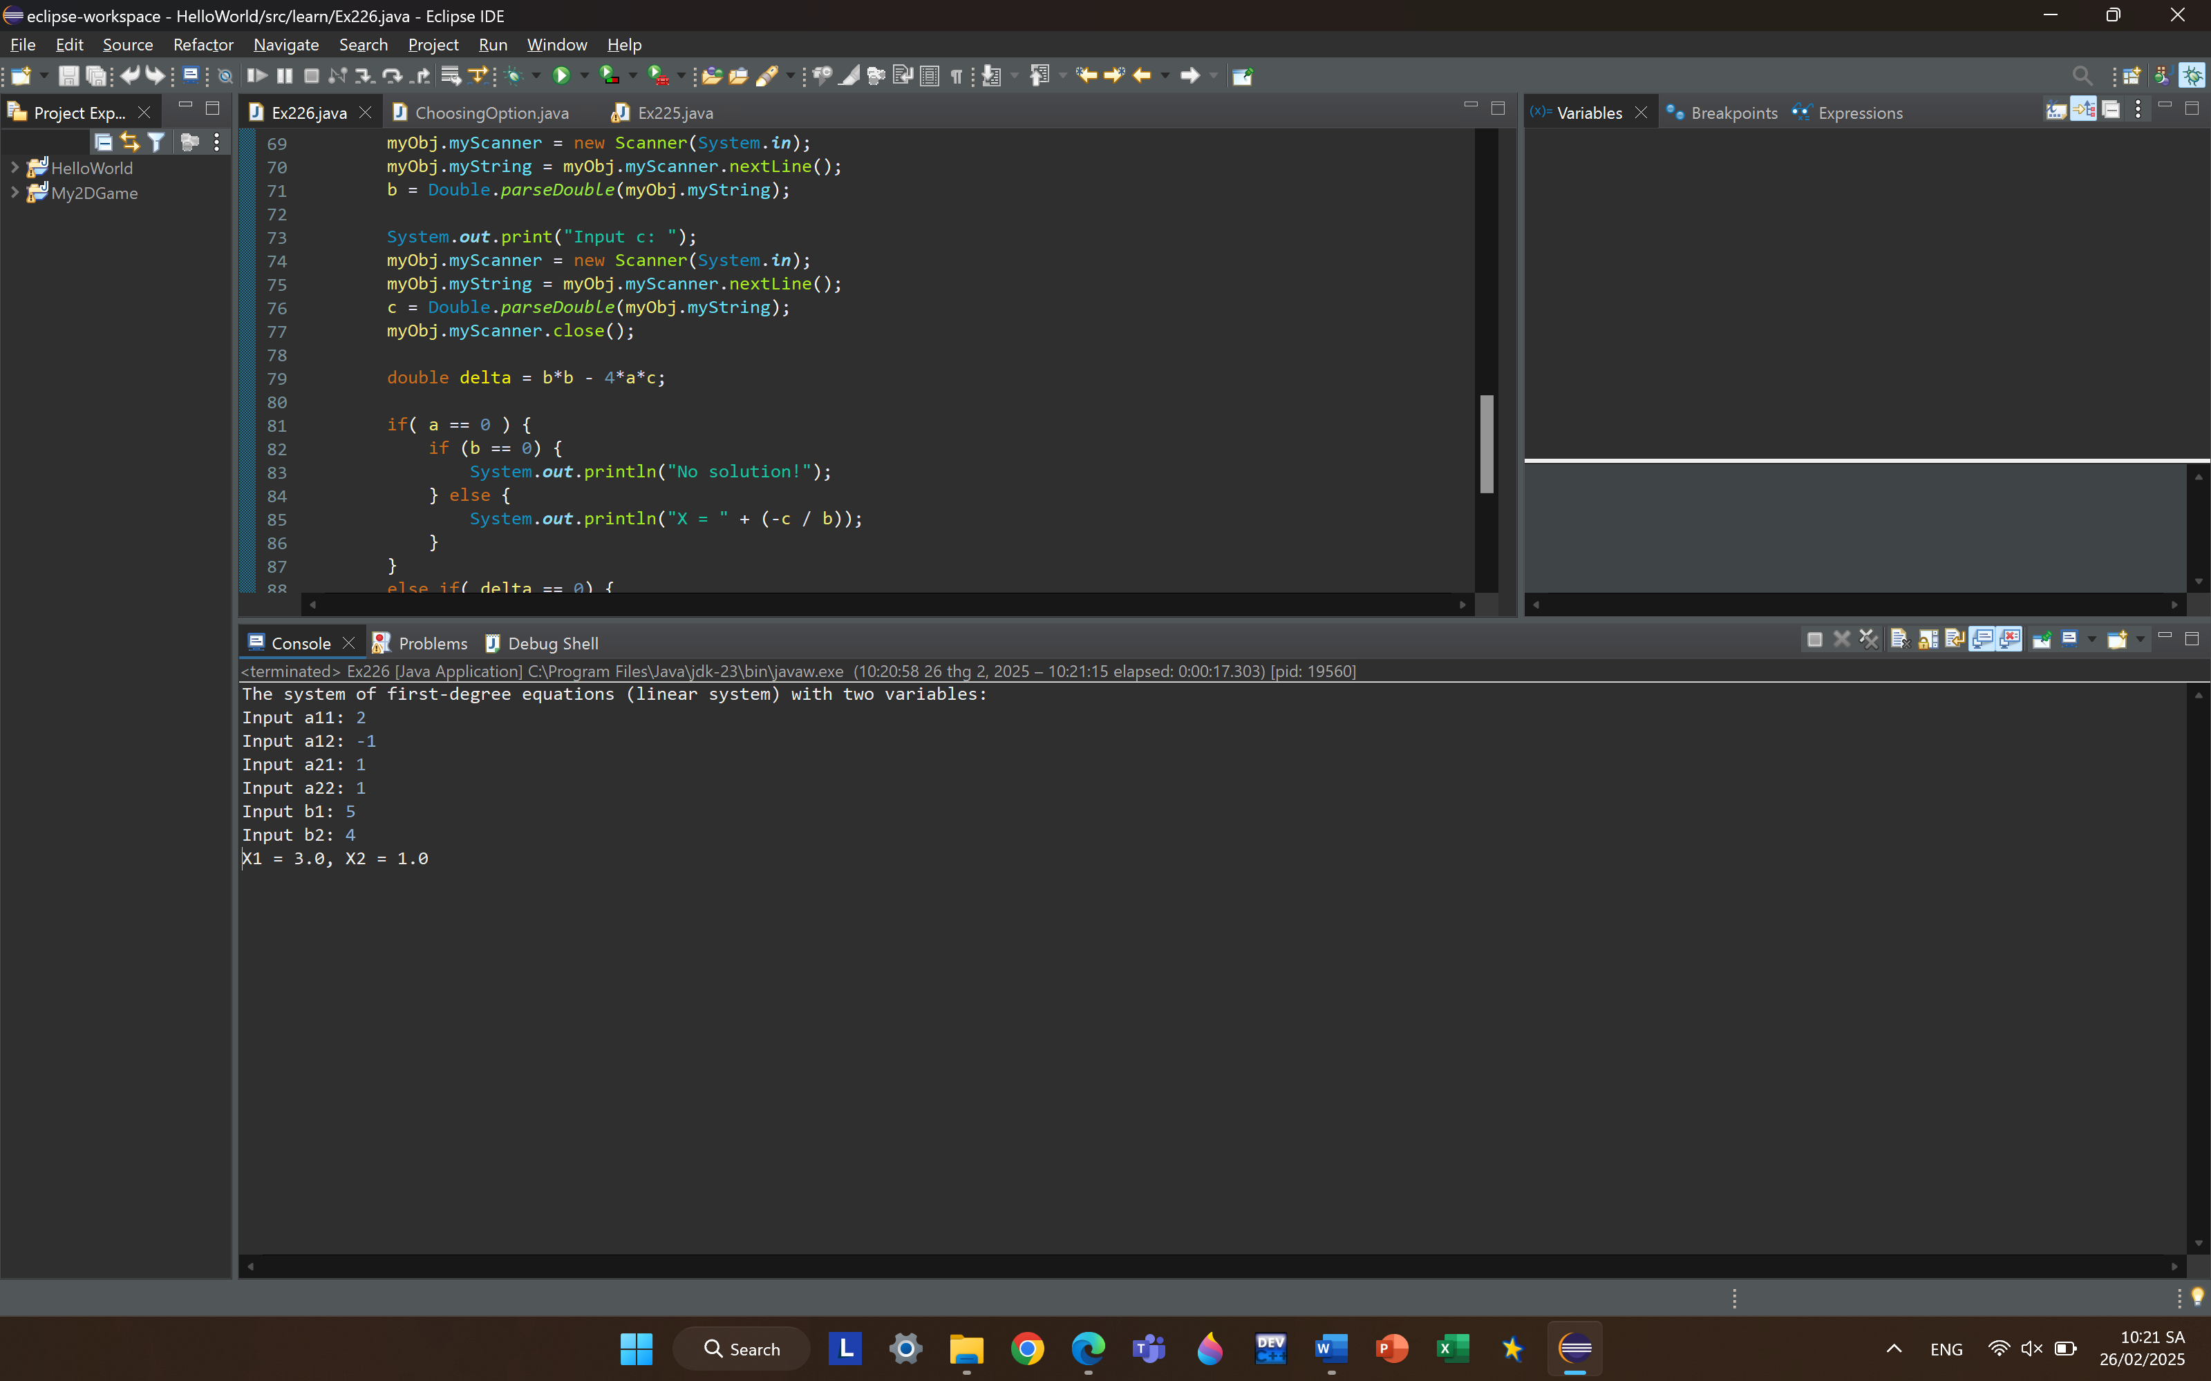

* The second-degree equation with one variable: 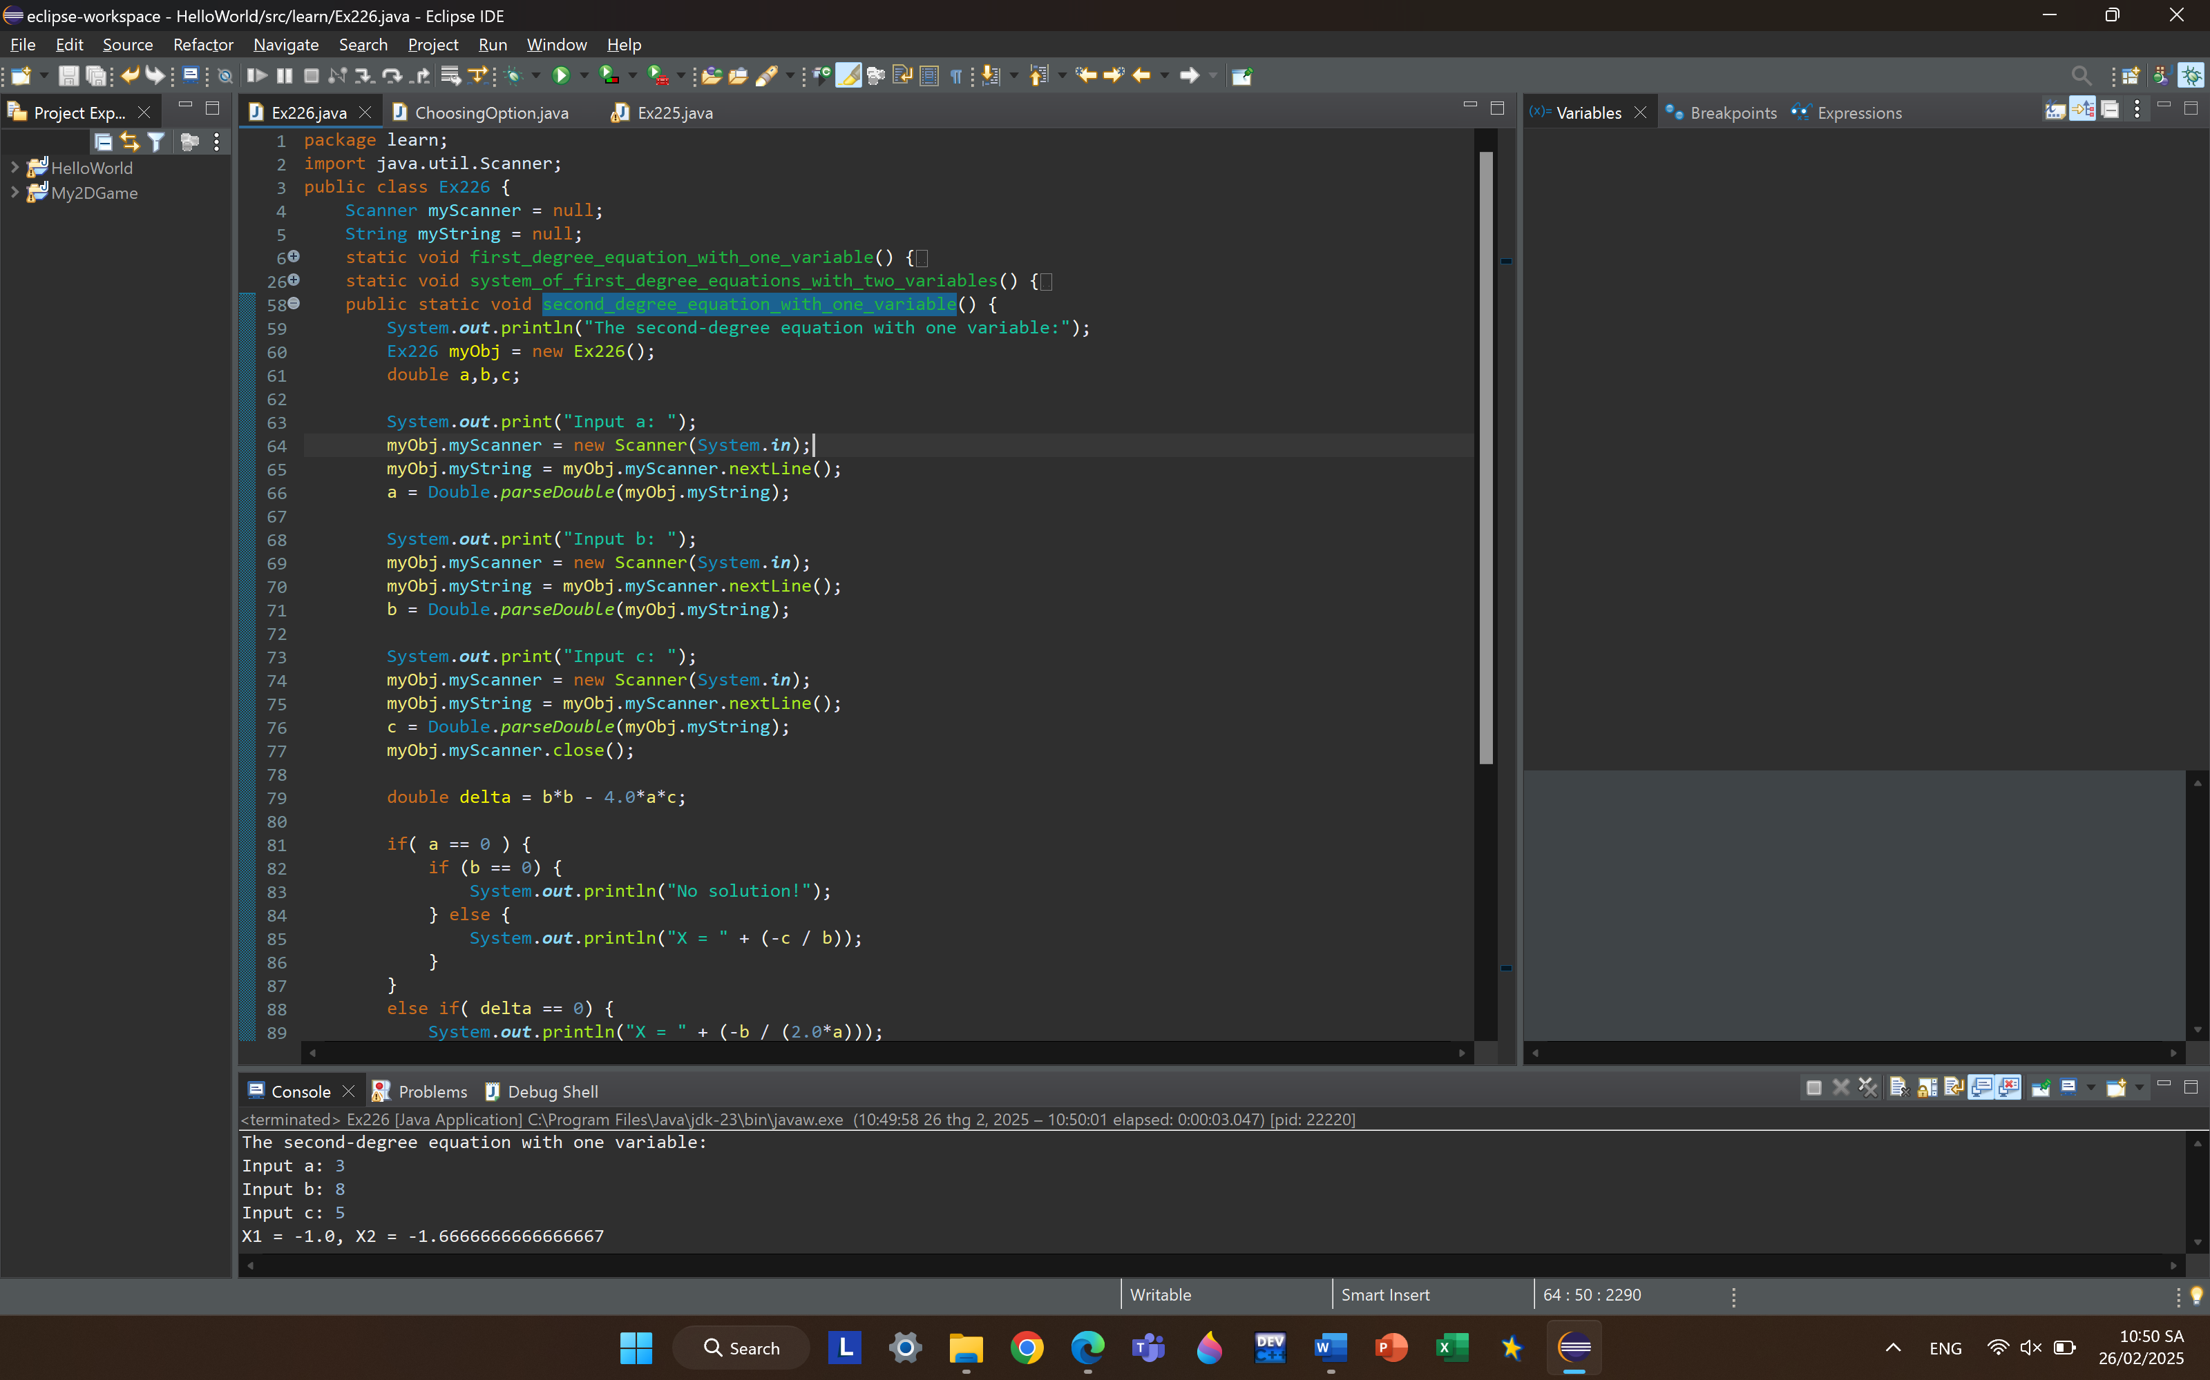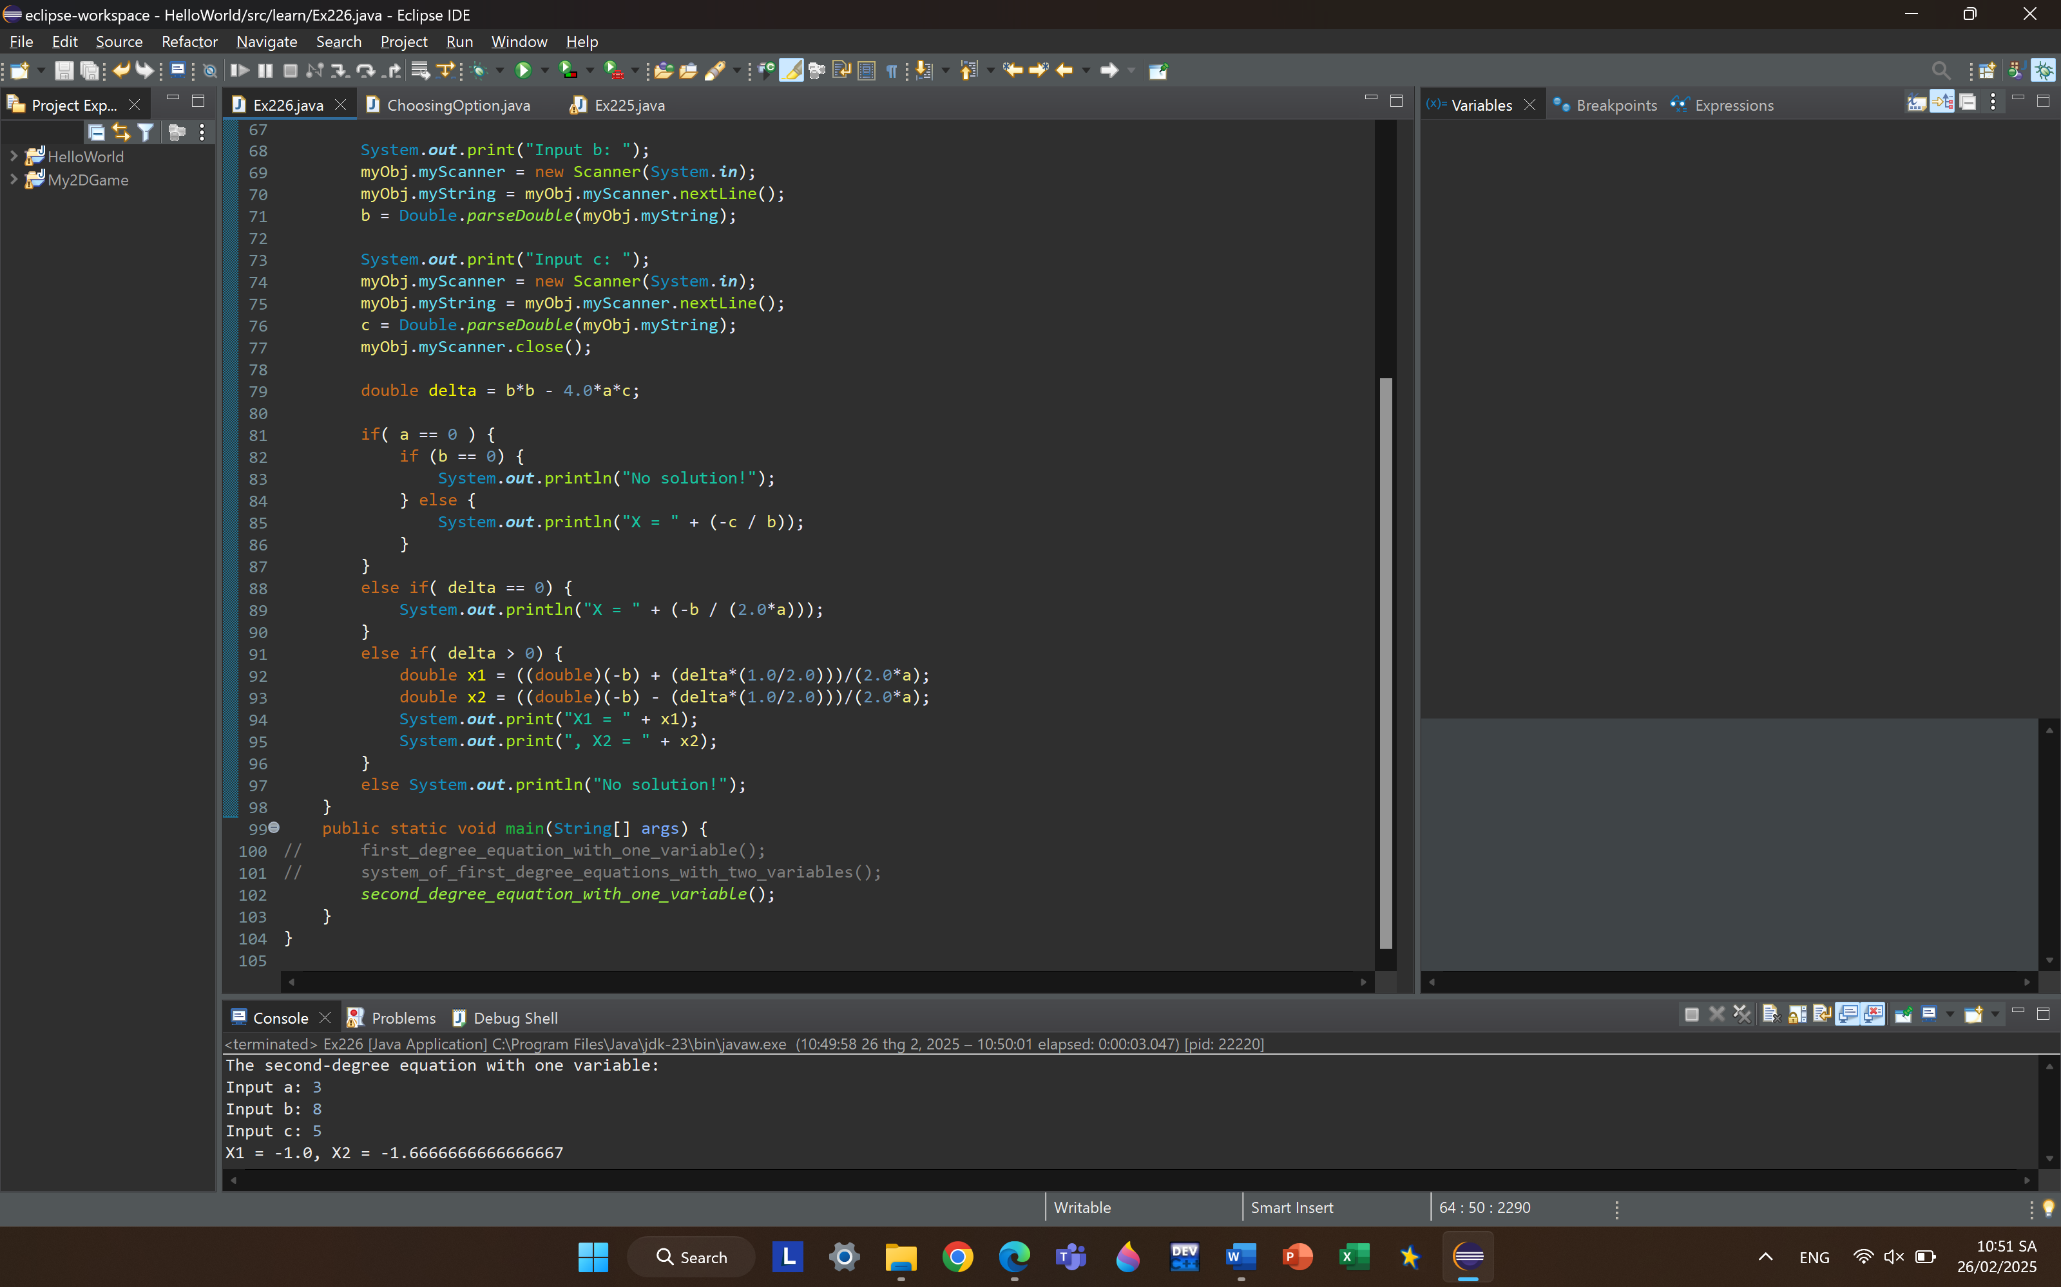

***6.1.*** Write, compile and run the ChoosingOption program: 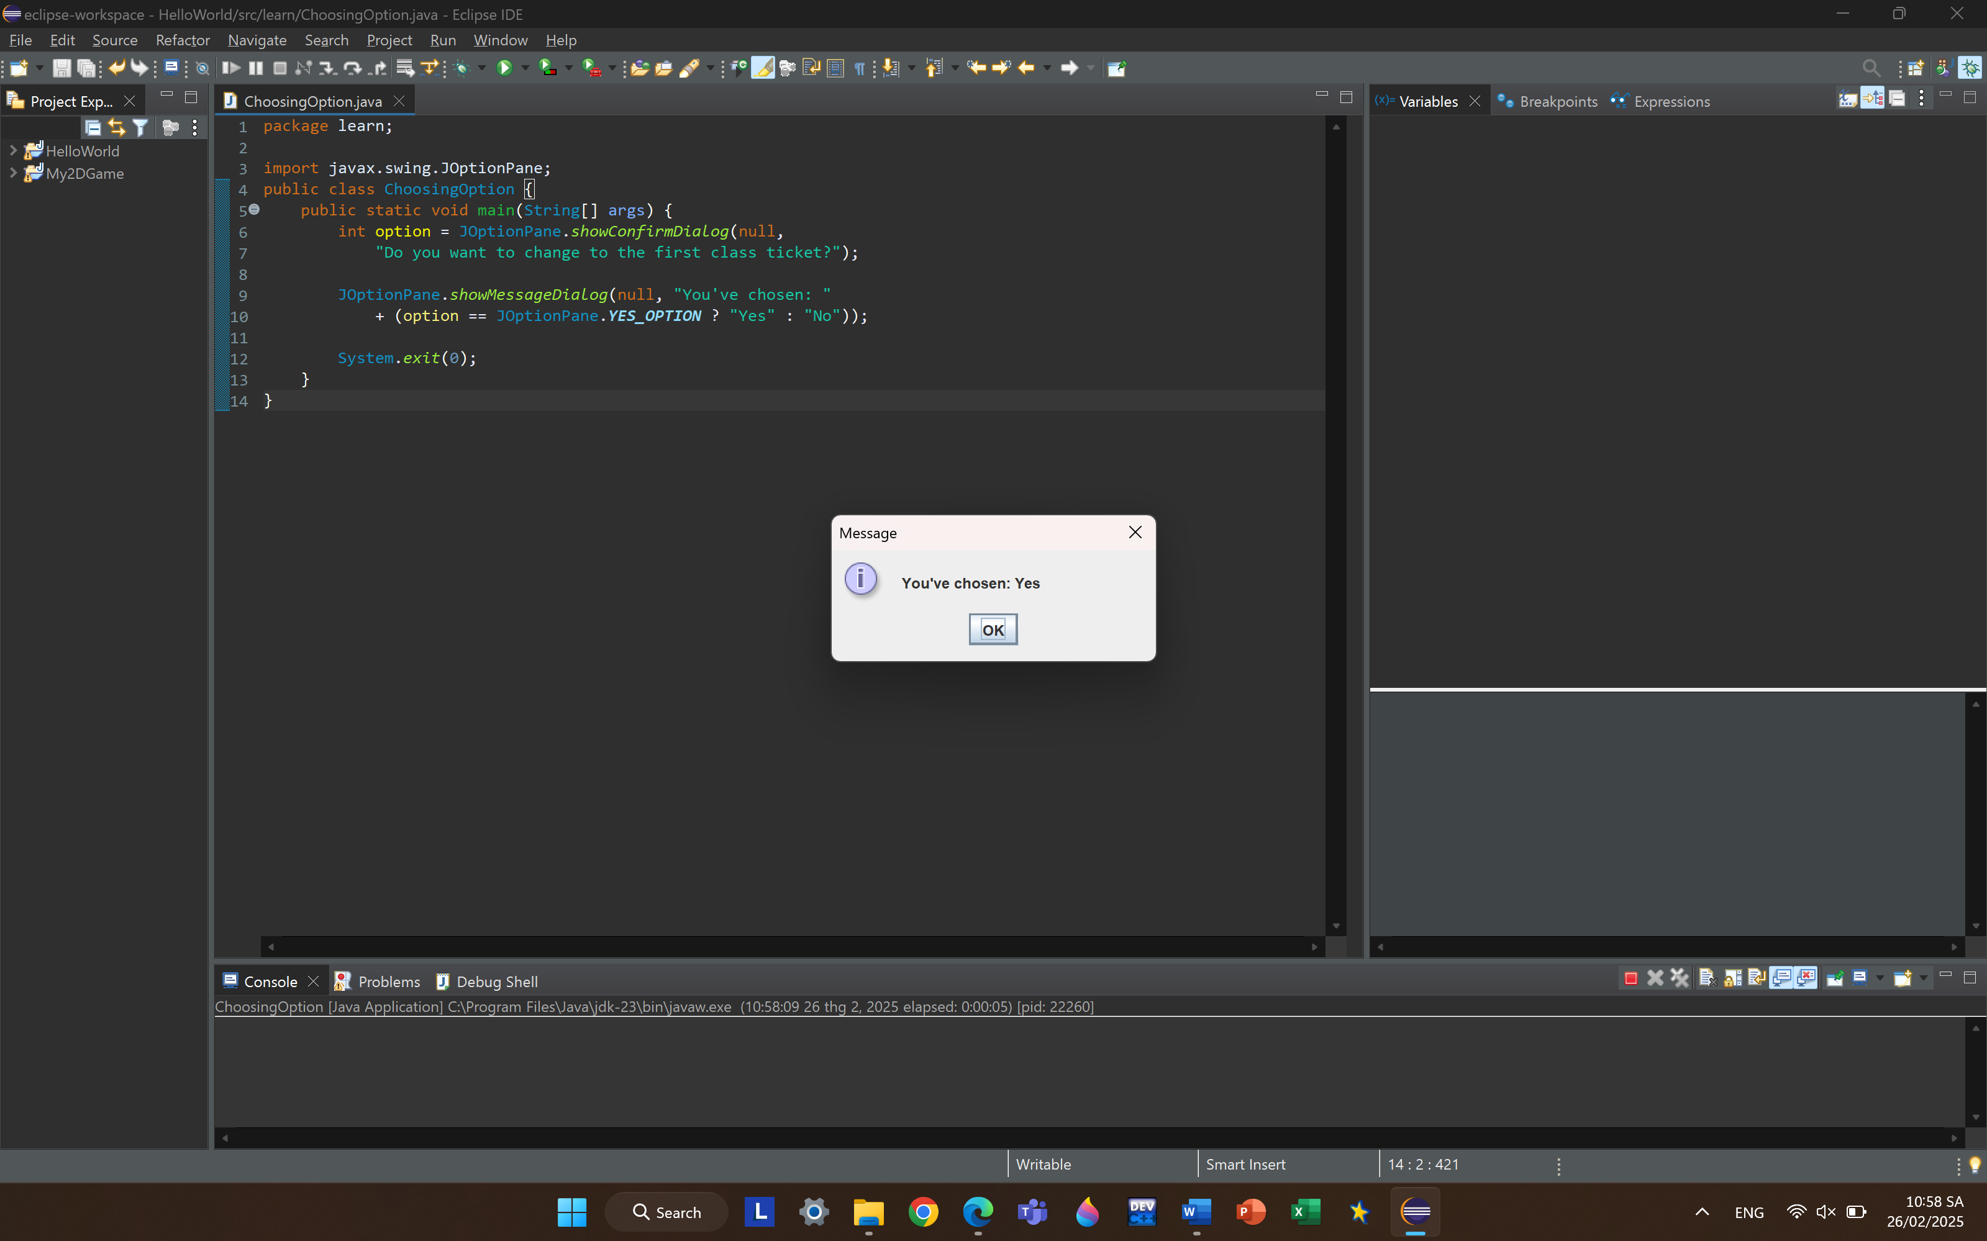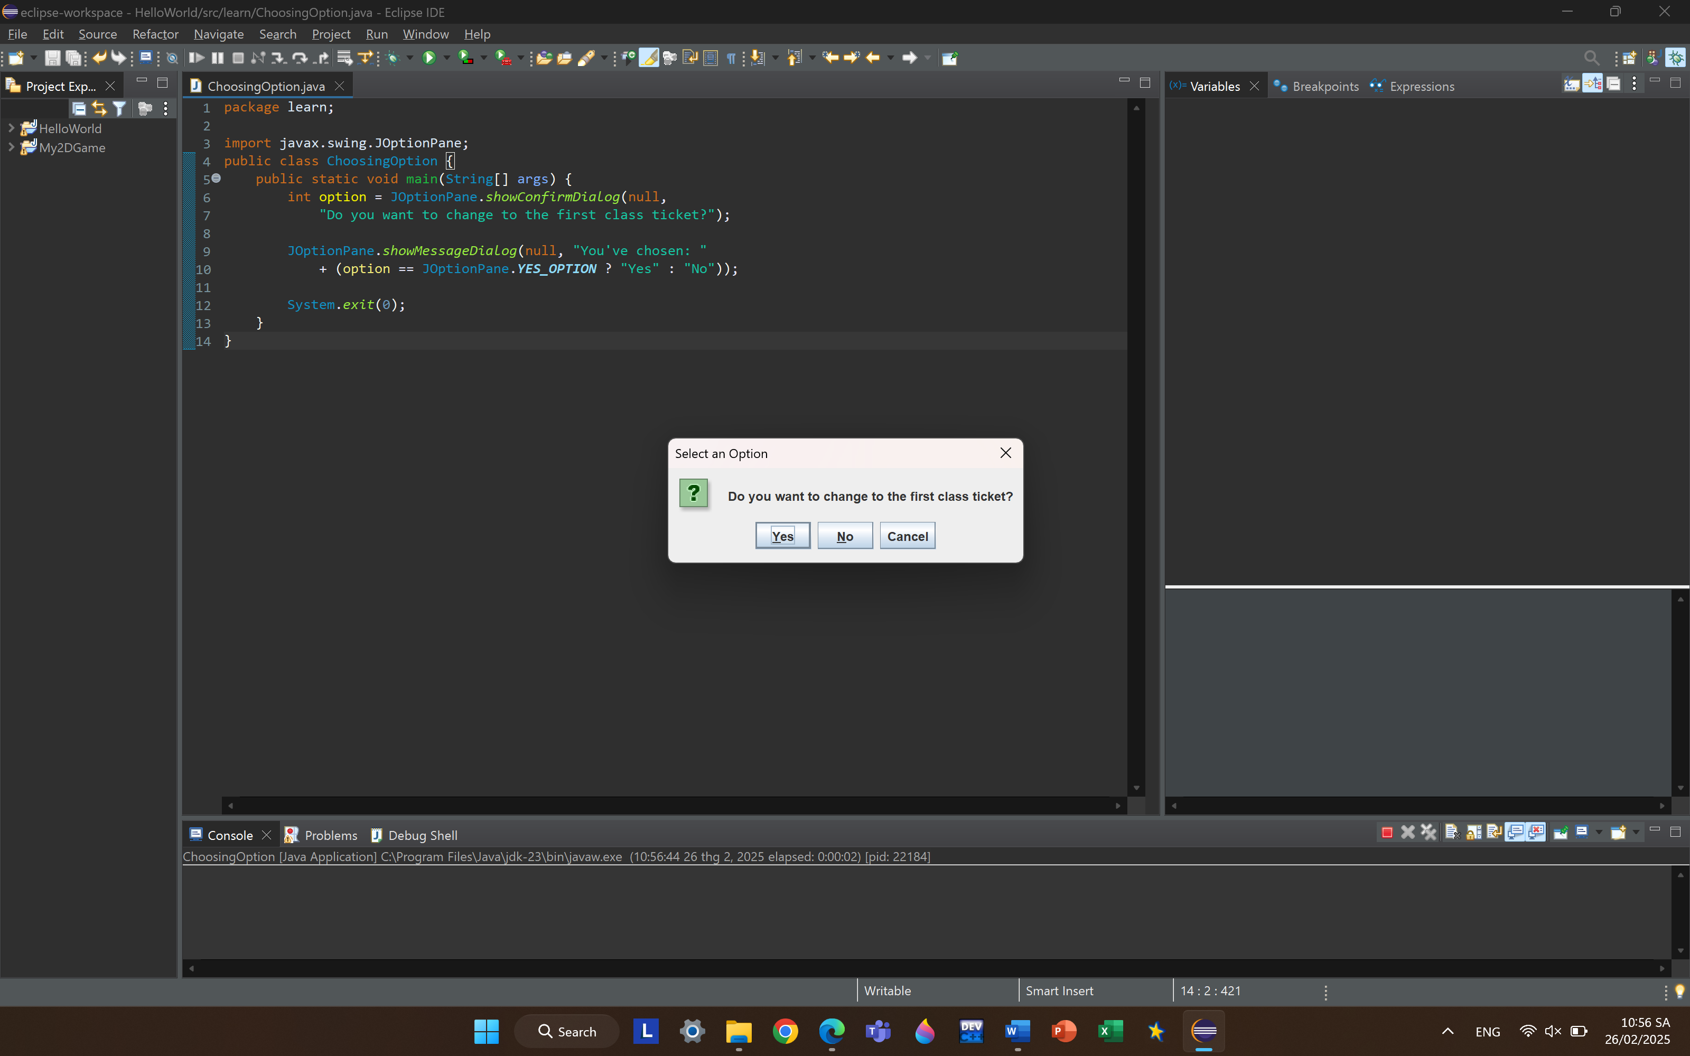

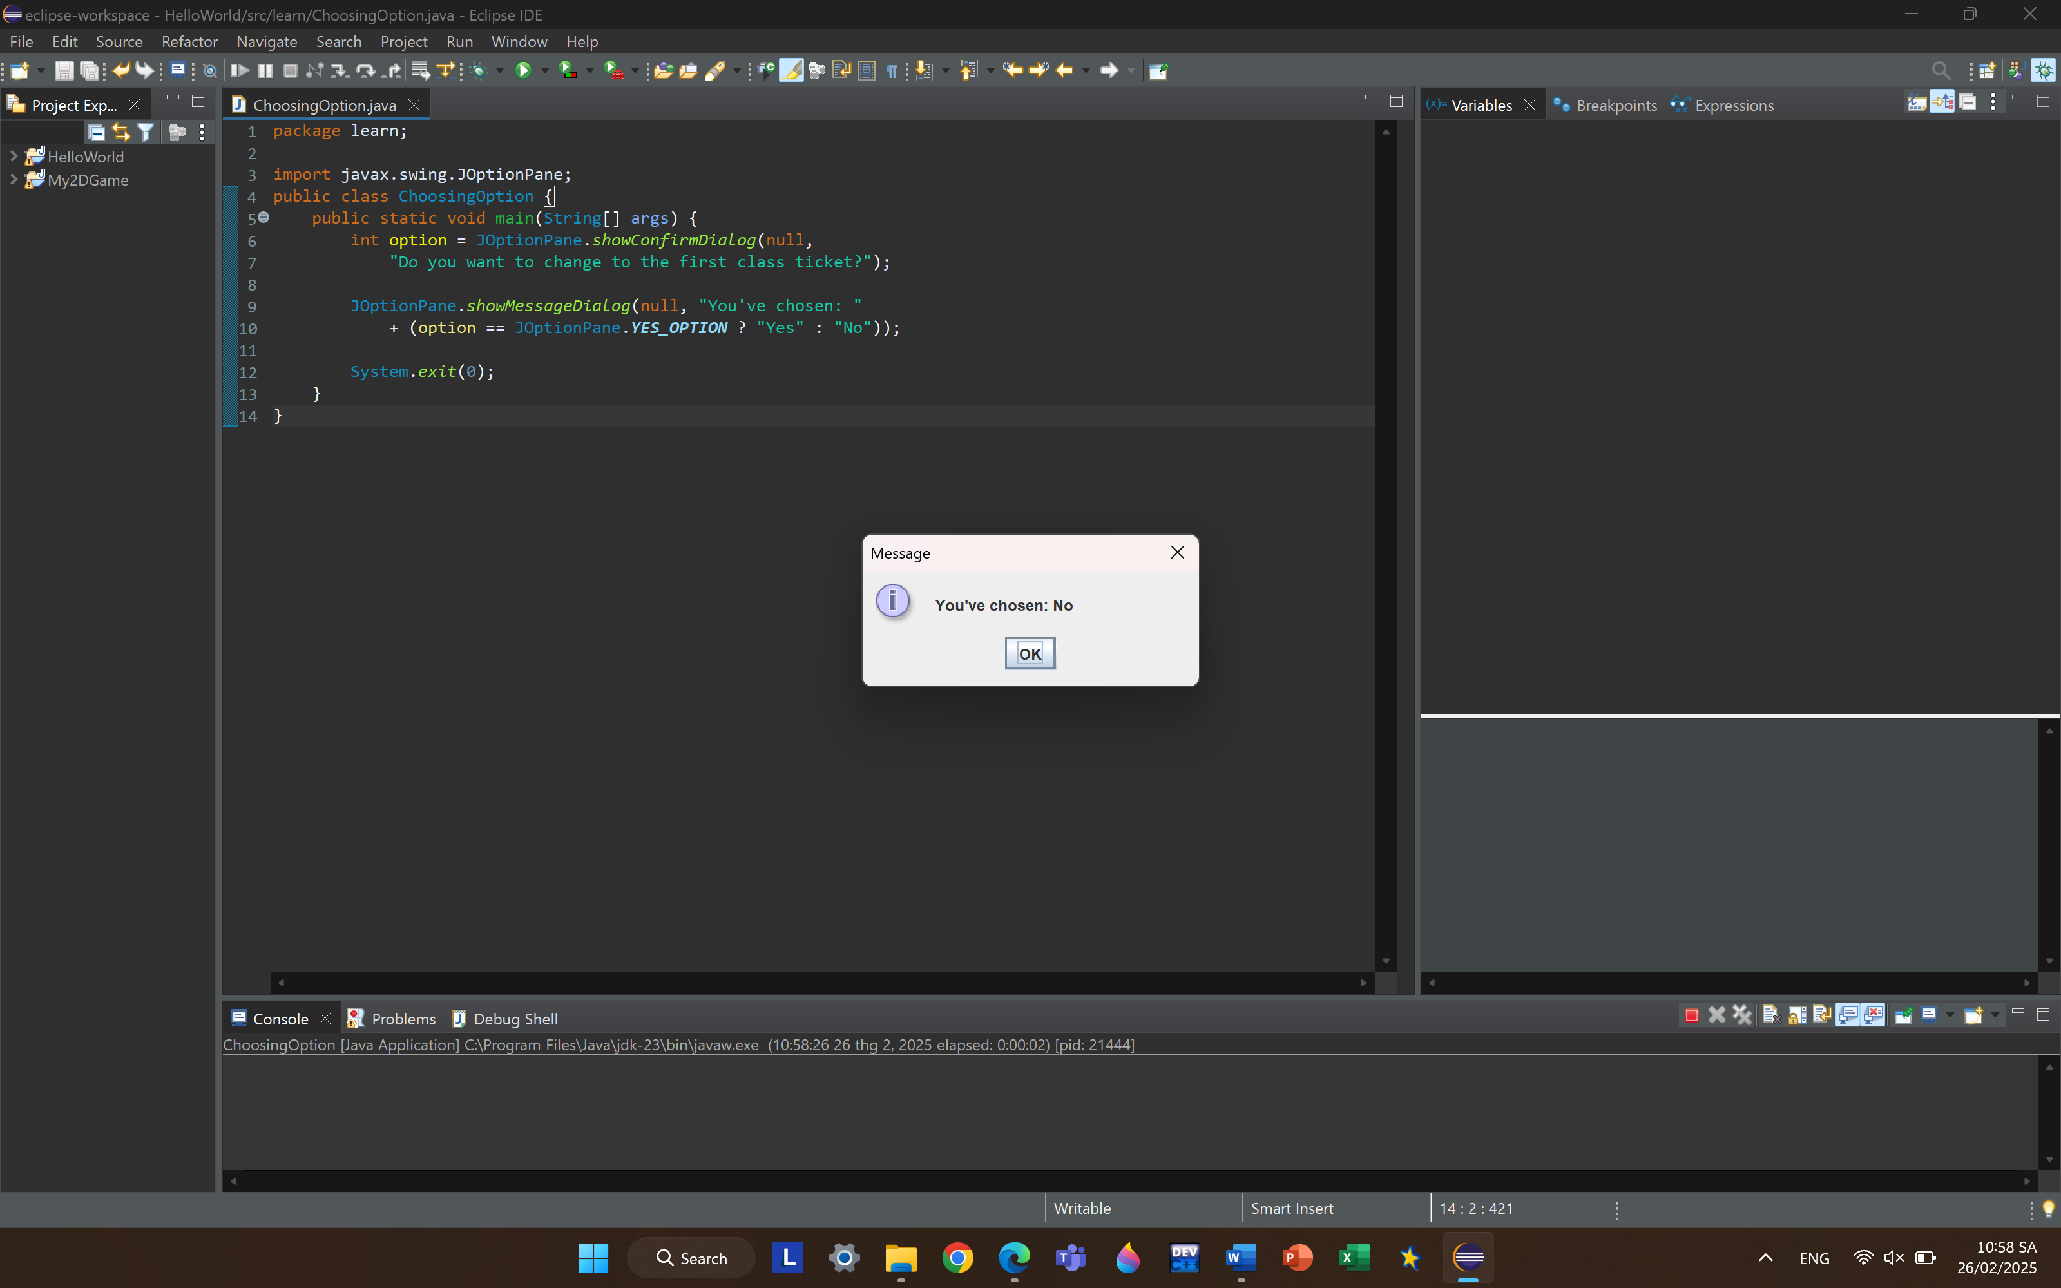

* Question:
* What happens if users choose “Cancel”?

It show the same as when we choose No :” You’ve chosen: No”.

* How to customize the options to users, e.g. only two options: “Yes” and “No”, OR “I do” and “I don’t” :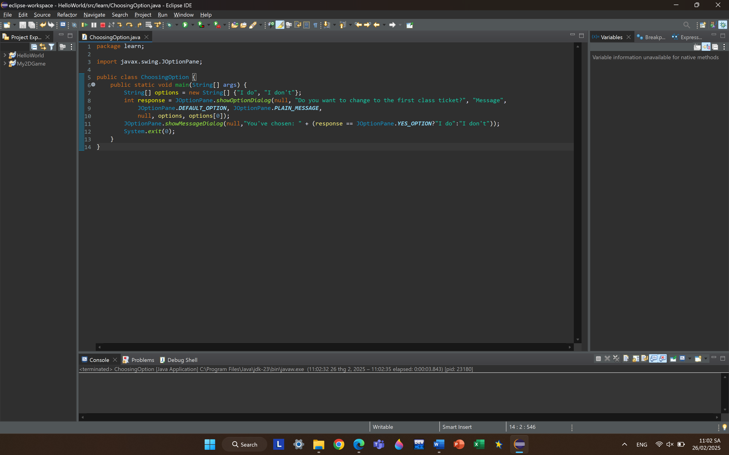

**6.2.** Write a program for input/output from keyboard:

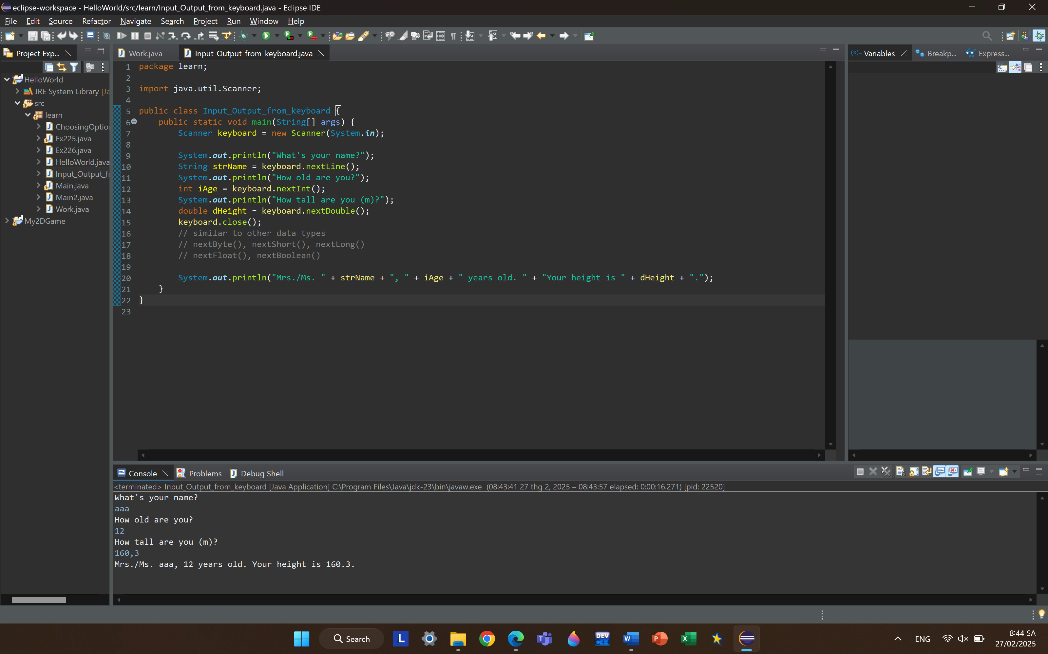

**6.3.** Write a program to display a triangle with a height of n stars (*), n is entered by users.

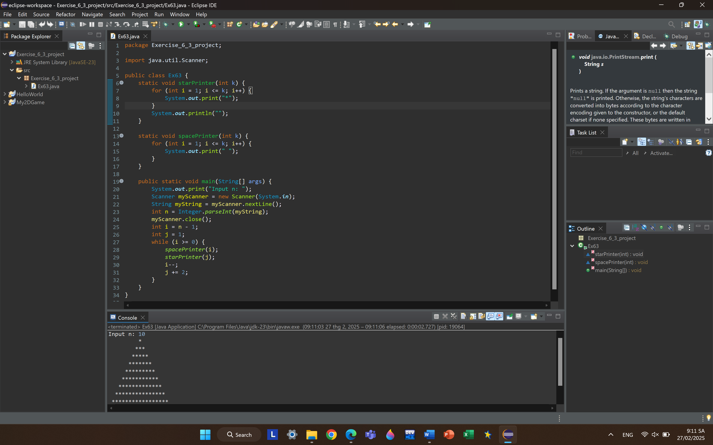

**6.4.** Write a program to display the number of days of a month, which is entered by users (both month and year). If it is an invalid month/year, ask the user to enter again.

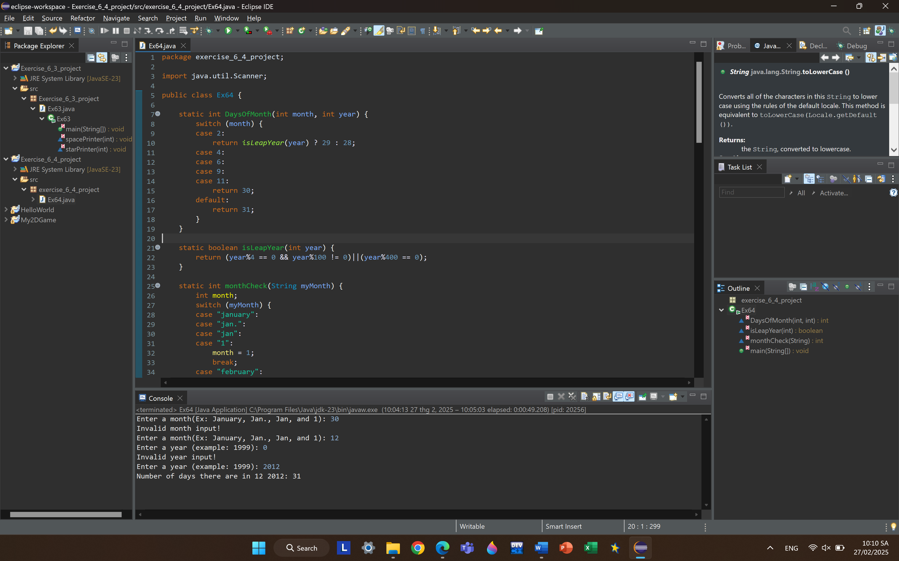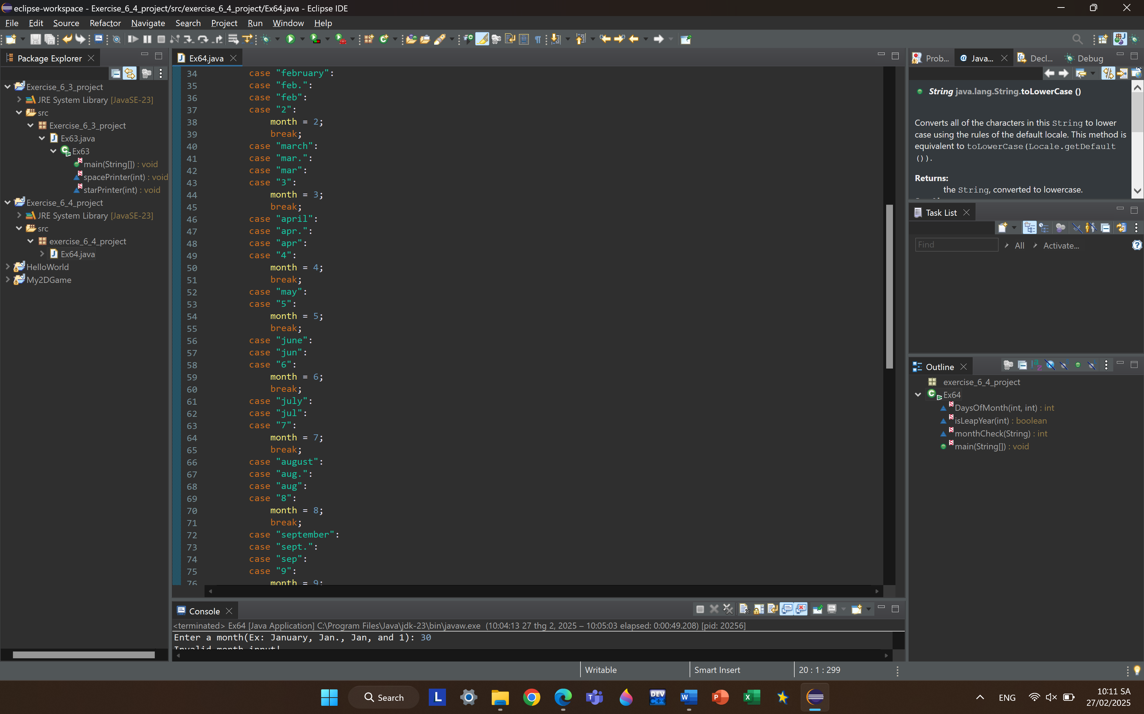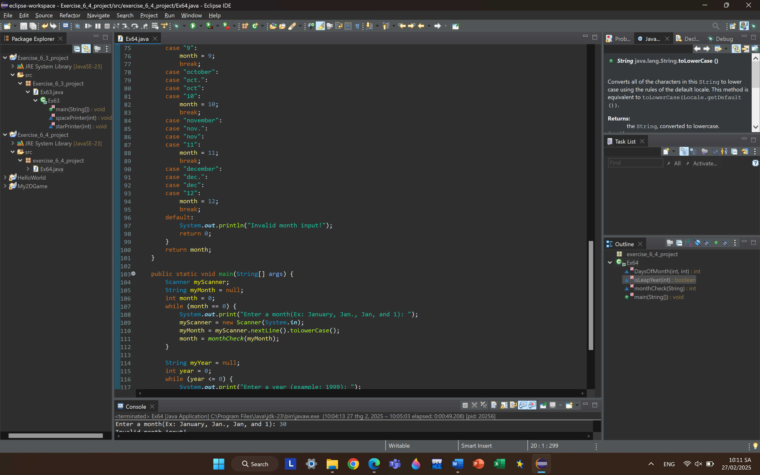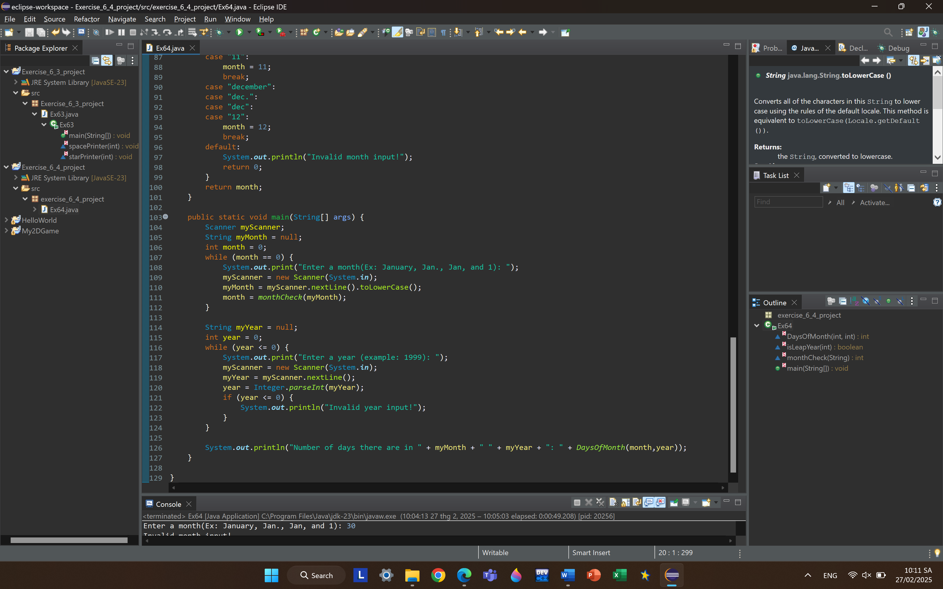

Result:

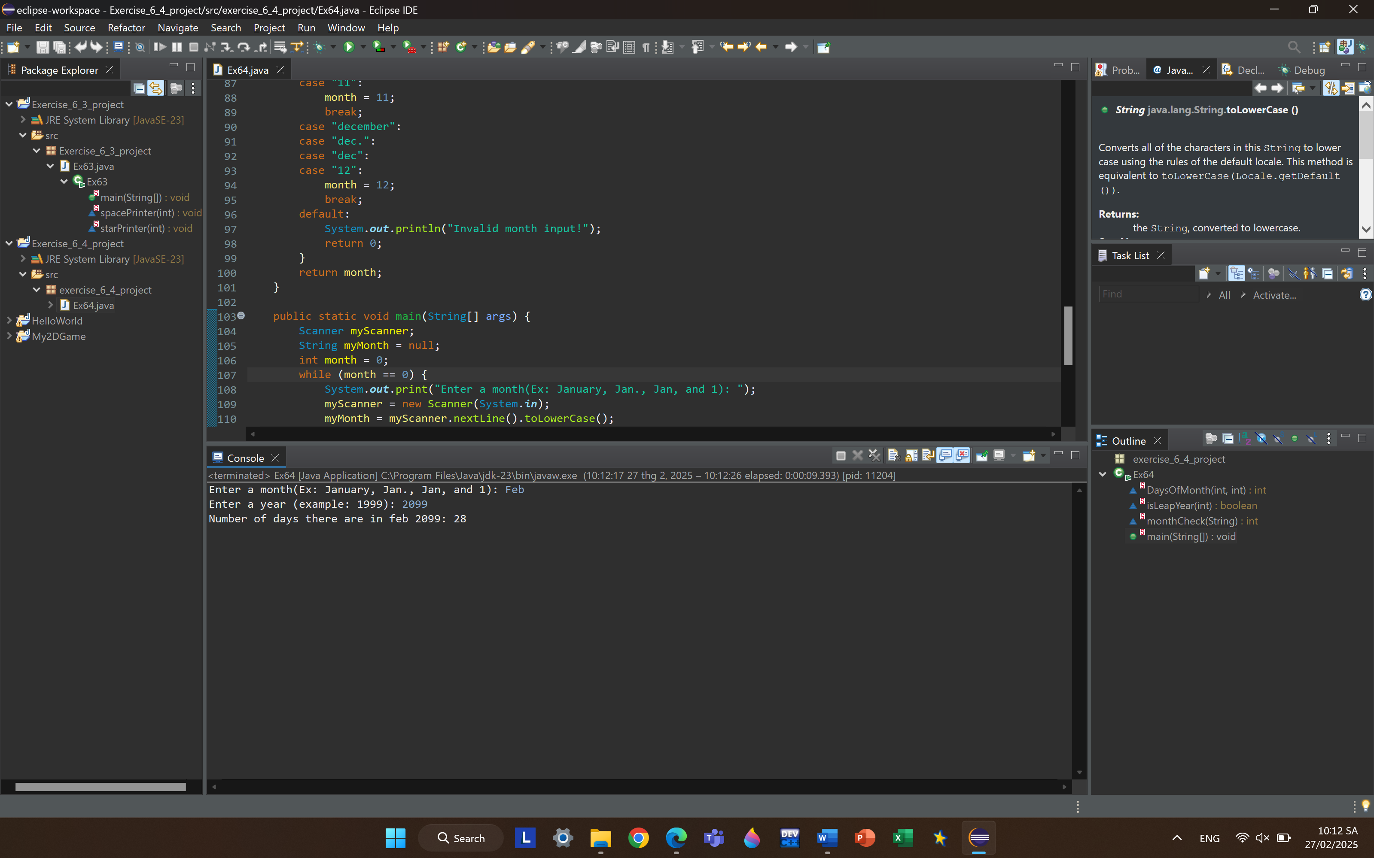

**6.5.** Write a Java program to sort a numeric array, and calculate the sum and average value of array elements.

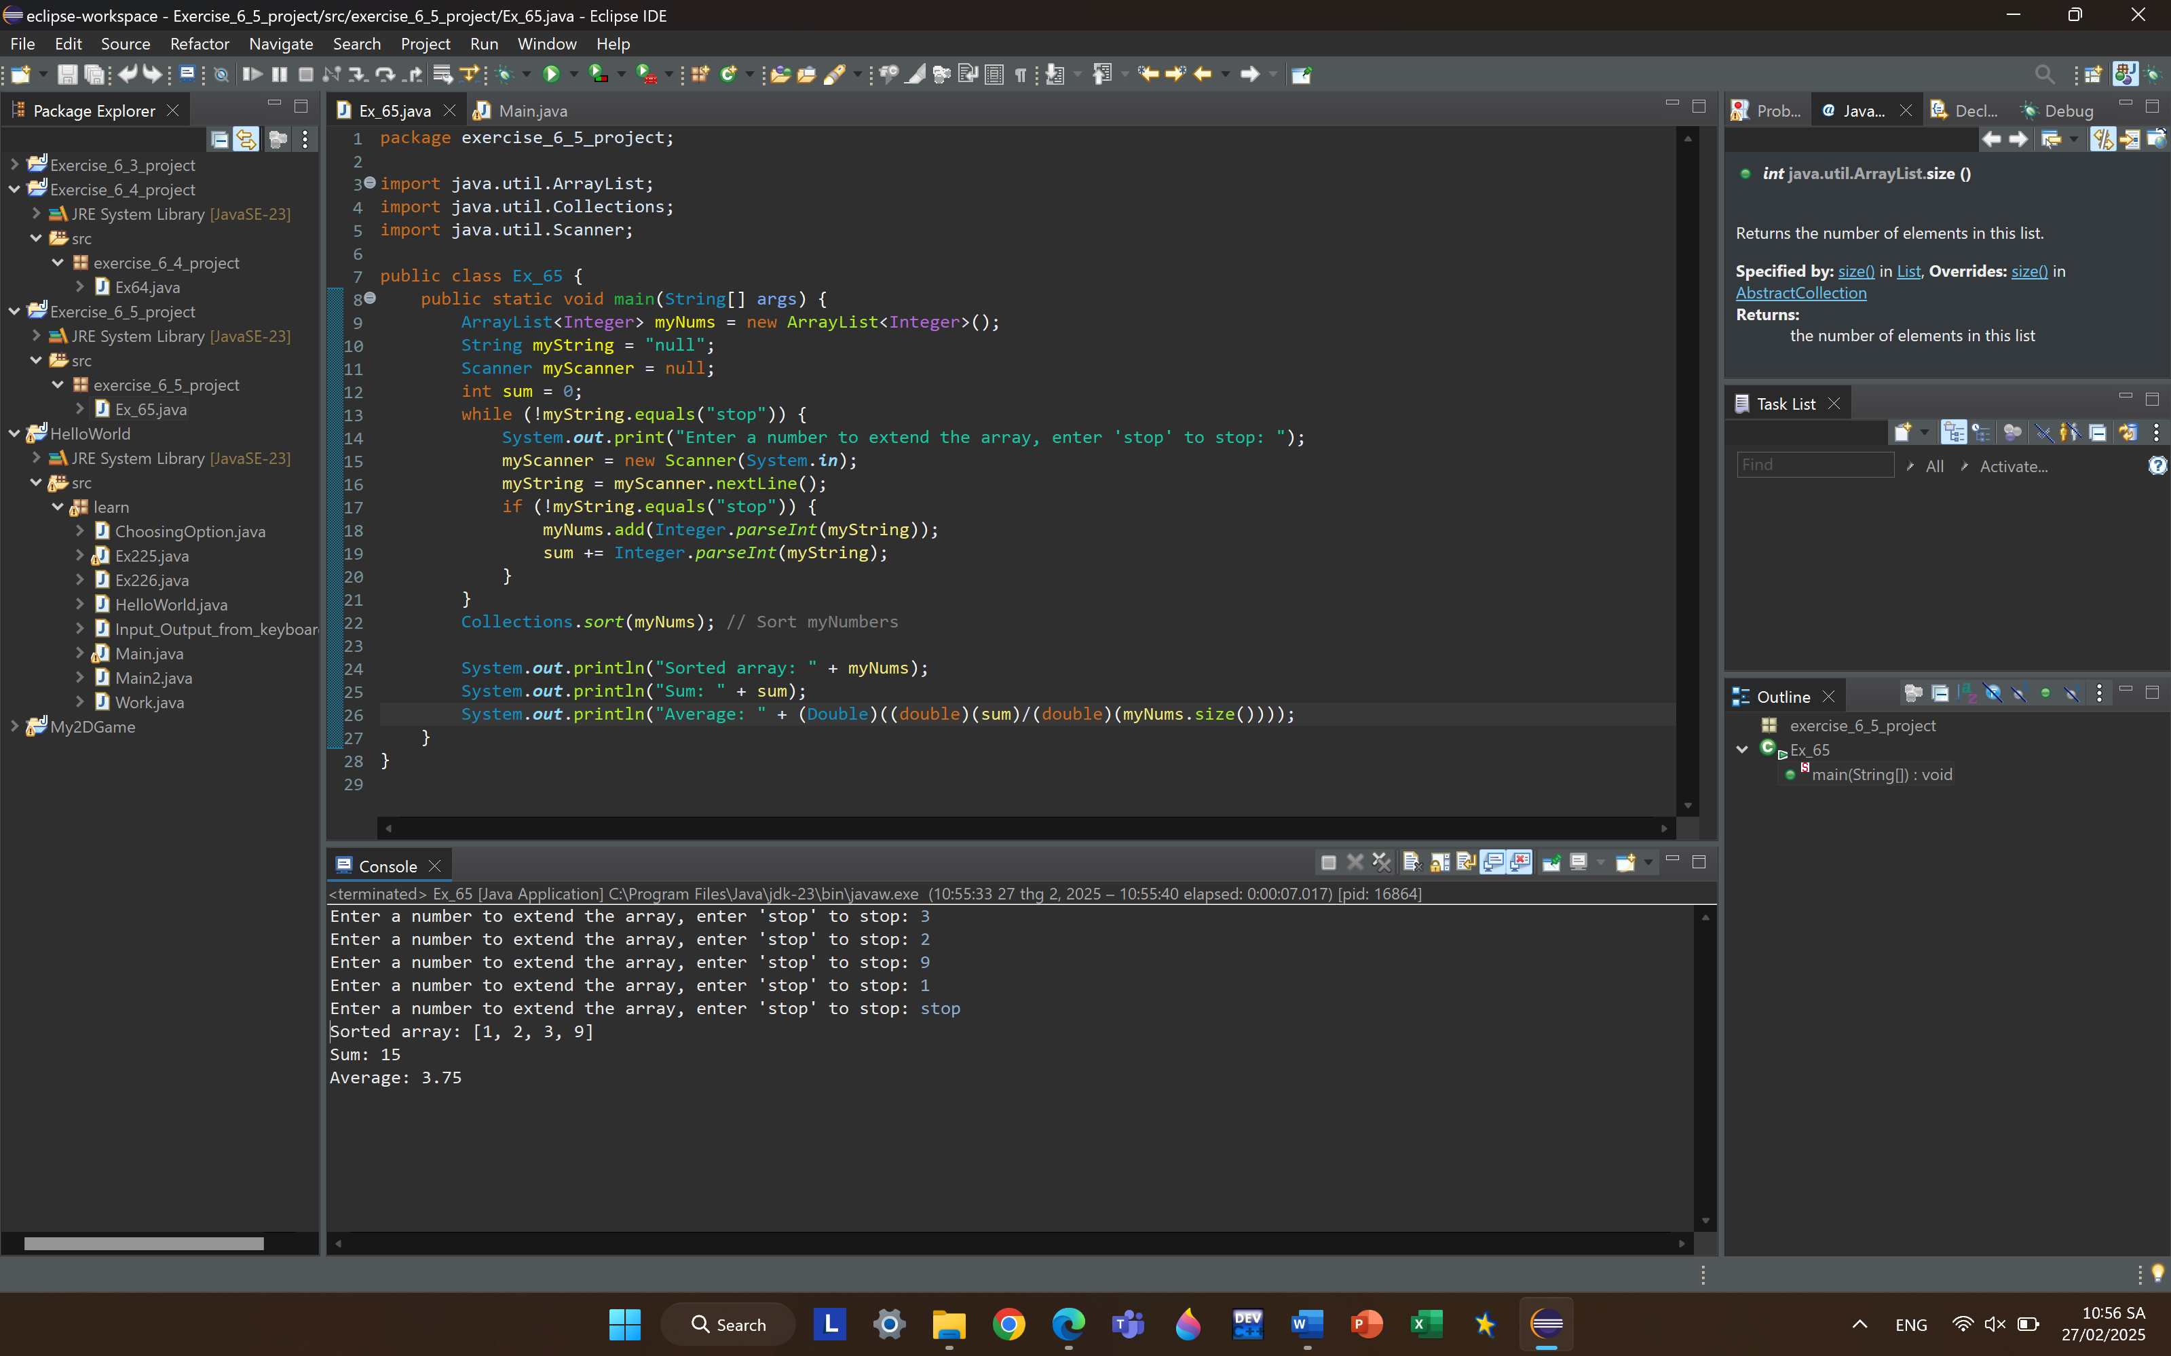

**6.6.** Write a Java program to add two matrices of the same size.

